High-Speed CMOS Logic

Dual 4-Input NOR Gate

notes:-

NC = No Connection (unused pin)

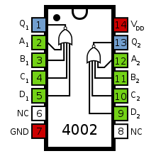

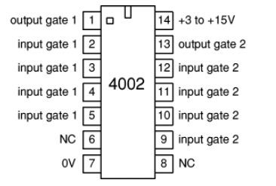

the proteus model is not working so we added the 4002 internal proteus gate

Code Pascal:-

